**Enterprise IT Infrastructure Setup Documentation**

**Overview**

This manual delivers detailed instructions for installing VMware Workstation and deploying Windows Server followed by Active Directory configuration and client machine domain joining before setting up Group Policies and optional Linux server and cloud service configurations on AWS/Azure.

**Table of Contents**

* Set Up VMware Workstation & Create Virtual Machines
* Install Windows Server on the VM
* Configure Windows Server & Enable Remote Desktop
* Set up Active Directory Domain Services (AD DS) on the system.
* Connect a Windows Client Machine to the Domain.
* Configure Group Policies
* Configure File Sharing & Remote Access
* Install and Configure a Linux Server
* Deploy Cloud Services on AWS

**Step 1: Set Up VMware Workstation & Create Virtual Machines**

**1.1 Install VMware Workstation**

Download VMware Workstation Pro.

**1.2 Create a New Windows Server Virtual Machine**

* Download Windows Server ISO image from this link [Windows Server ISO Download](https://www.microsoft.com/en-us/evalcenter/download-windows-server-2022?msockid=046233a44ef9696623a2279c4ff668f1)
* Open VMware Workstation to launch "Create a New Virtual Machine" and select "Custom (advanced)" to choose the Windows Server ISO.
* Launch VMware Workstation and select "Create a New Virtual Machine".
* Navigate to "Custom (advanced)" and select the Windows Server ISO file.
* Assign 2-4 CPUs alongside 4GB or more RAM and a minimum of 60 GB Disk Space to the virtual machine.
* Run the setup wizard and start up the VM.

**1.3 Create a Ubuntu Server Virtual Machine**

* Download Ubuntu Server ISO image from this link [Ubuntu Server ISO Download](https://ubuntu.com/download/server)
* Set up a Virtual Machine for Linux by following the same procedure described earlier using a Linux ISO file.

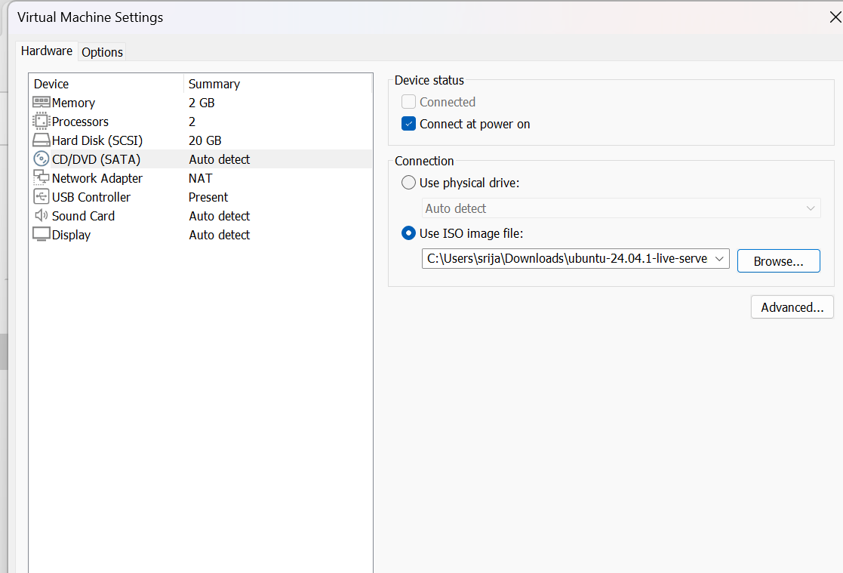

* Use the same procedure from above for setting up a virtual machine with a Linux ISO such as Ubuntu Server.
* Assign 2 CPUs and provide between 2 to 4 GB of RAM along with a minimum of 20 GB of Disk Space.

**Step 2: Install Windows Server on the VM**

**2.1 Boot and Install**

* Initiate the VM power sequence to start booting from the ISO file followed by language selection.
* Select the "Install Now" option and proceed to pick Windows Server 2022 Standard.

**2.2 Partition & Install**

* Select "Custom: Install Windows Only (Advanced)".
* Select unallocated disk space to use → Perform formatting when necessary → Press "Next" to continue.
* Set Administrator password when prompted.

**Step 3: Configure Windows Server & Enable Remote Desktop**

**3.1 Basic Configuration**

* Log in → Open Server Manager → Rename computer.
* Configure Static IP: Control Panel → Network Settings.

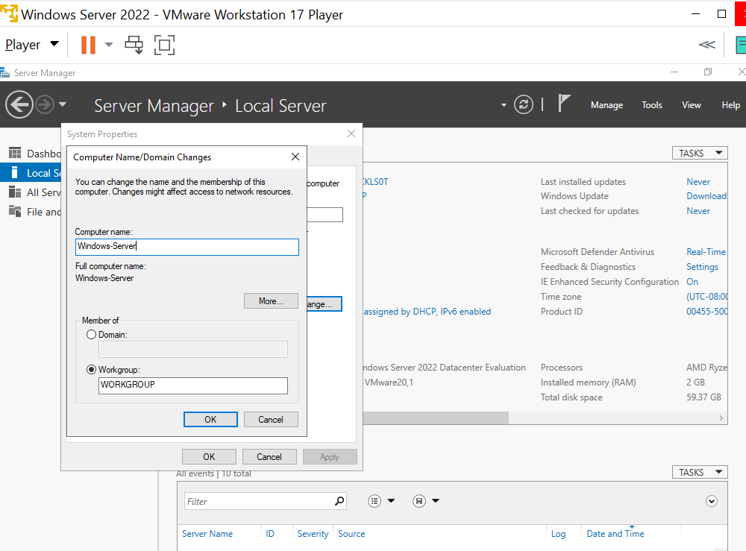

**3.2 Enable Remote Desktop (RDP)**

* Open Server Manager → Enable "Allow remote connections".
* Apply settings and restart.

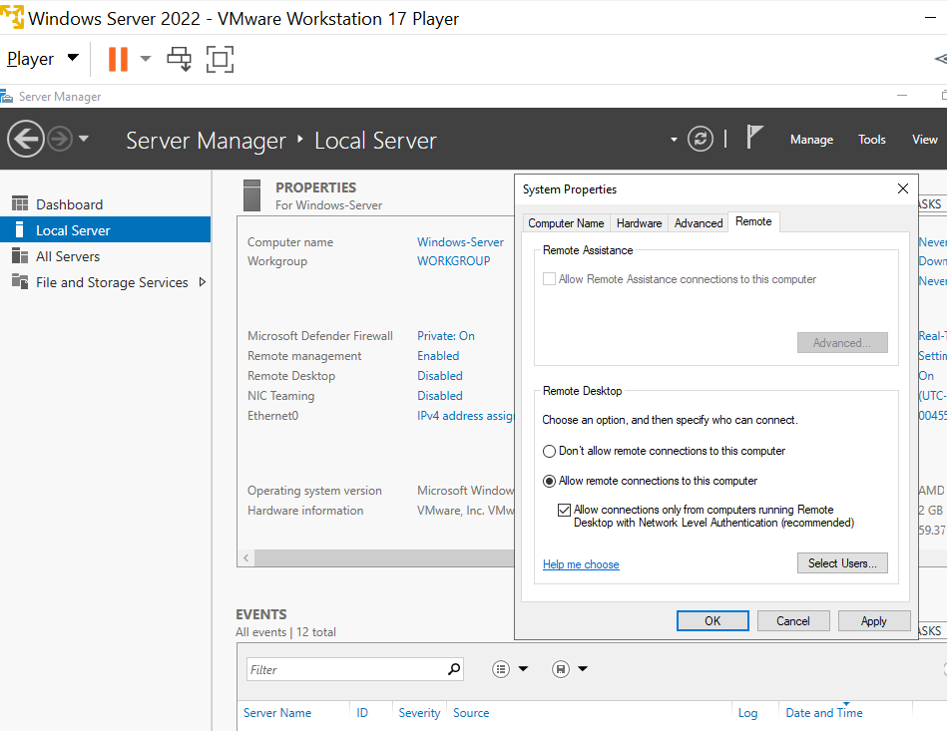

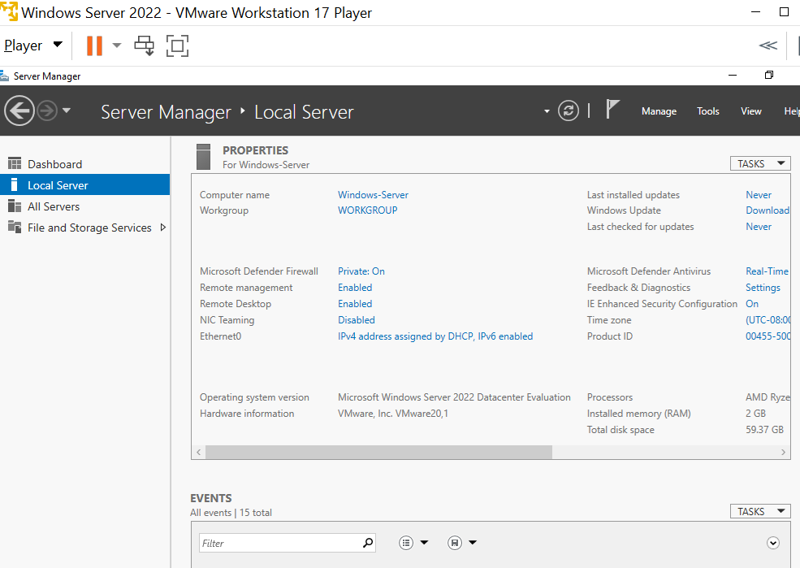

**Step 4: Set up Active Directory Domain Services (AD DS) on the system.**

**4.1 Install AD DS Role**

* Server Manager → "Add Roles and Features".
* Select "Active Directory Domain Services" → Install.

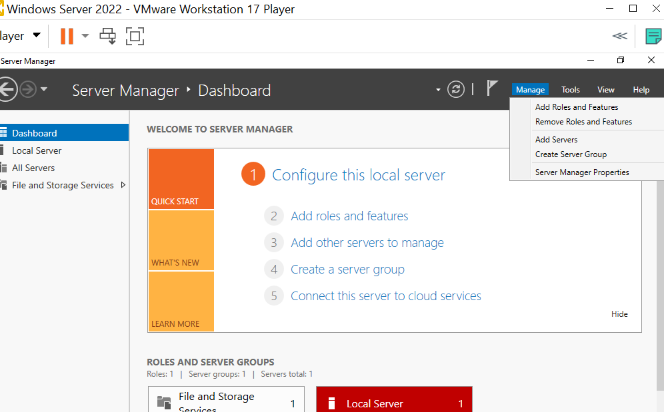

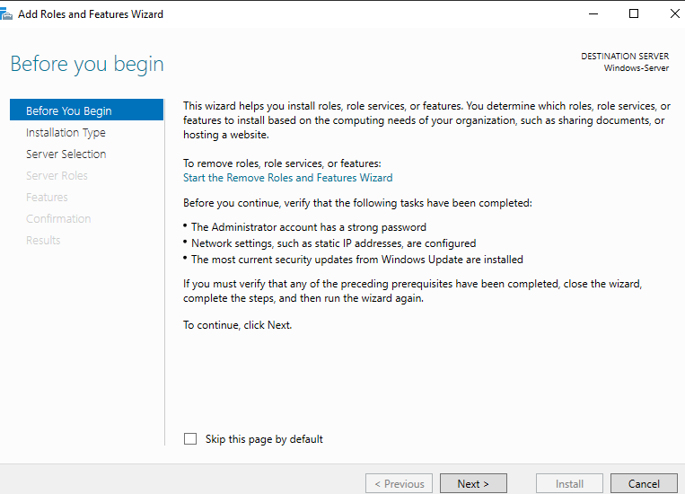

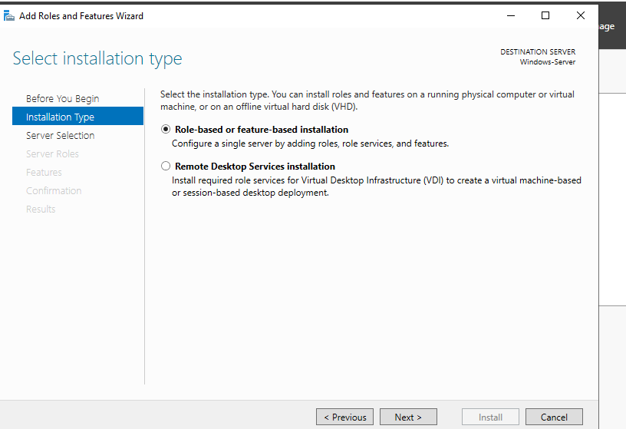

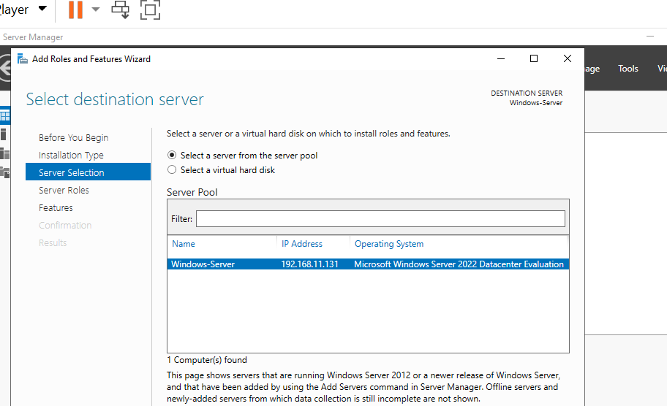

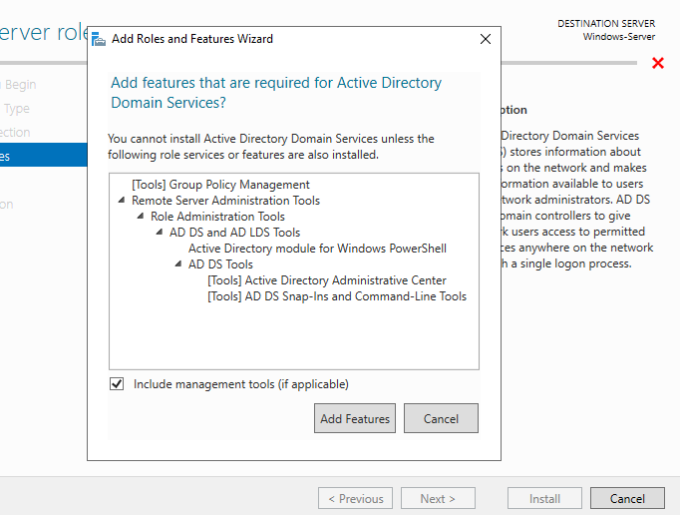

**4.2 Promote to Domain Controller**

* To promote the server to a domain controller select Notification and then choose the option "Promote this server to a domain controller".
* Select "Add a new forest" and then define the domain name (for example, mycompany.local).
* Configure settings → Install → Restart.

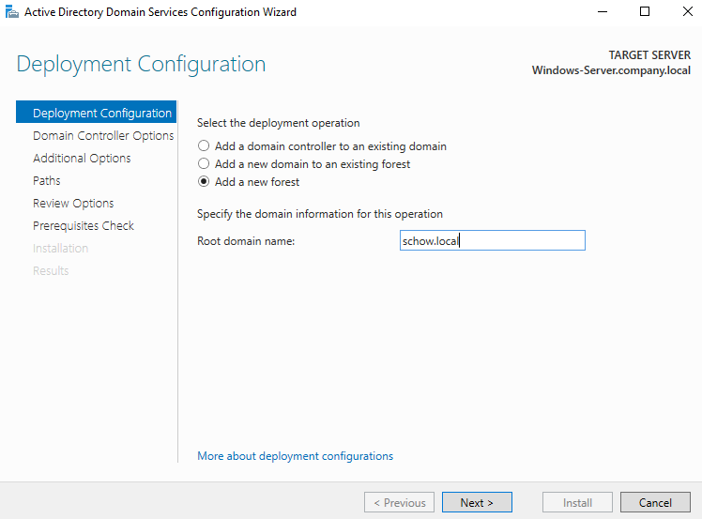

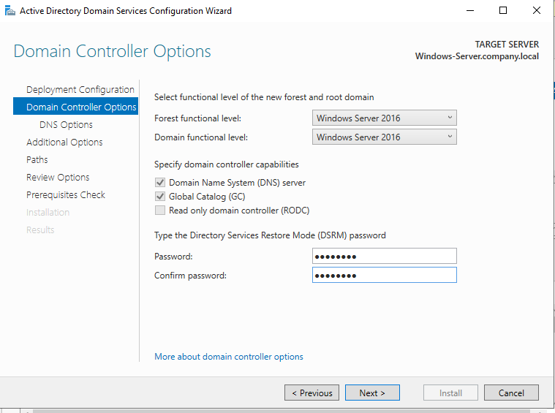

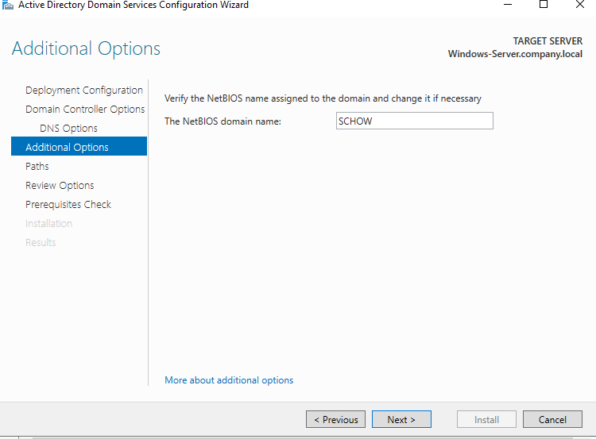

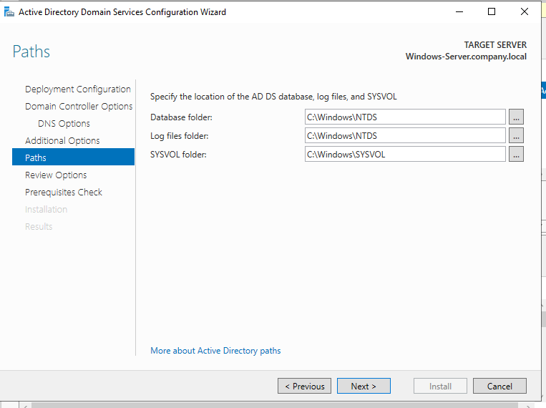

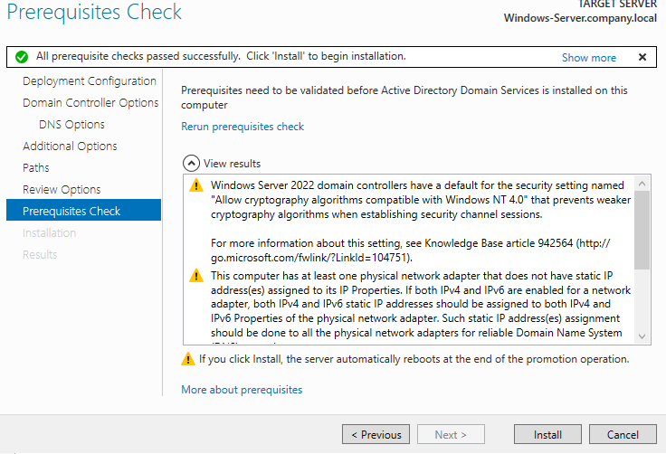

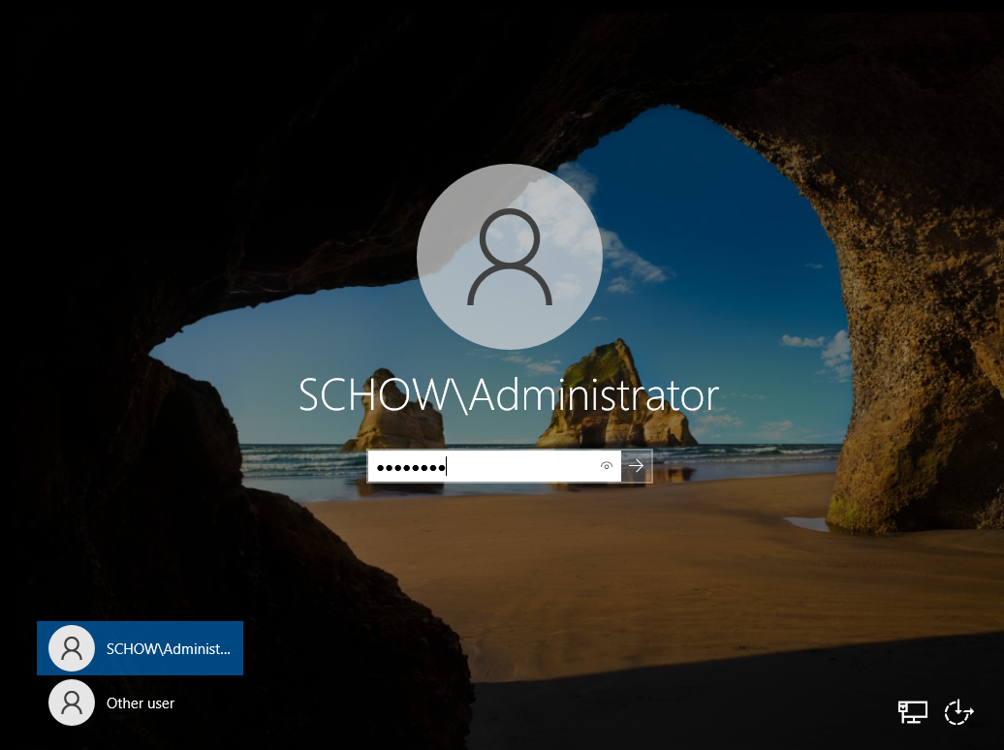

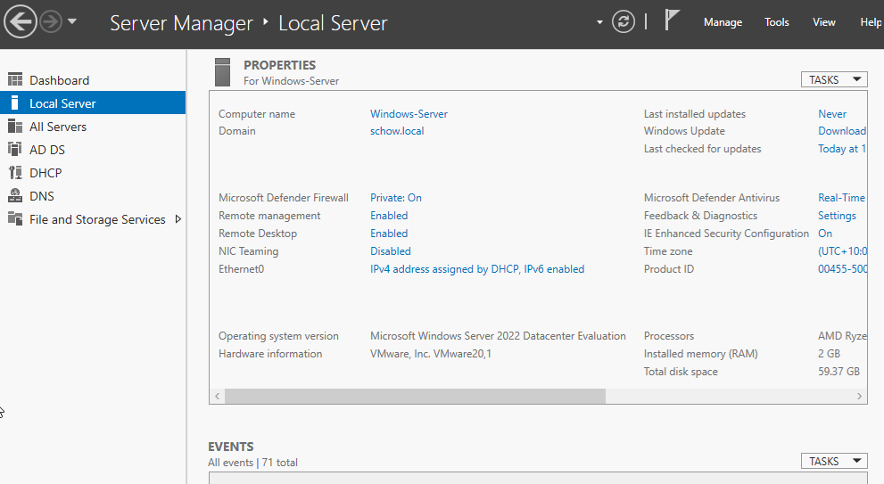

**4.3 Verify AD DS Installation**

Access the "Active Directory Users and Computers" interface to validate the domain name, and create a new user and add them to a domain user group or create a new group if necessary using the following steps.

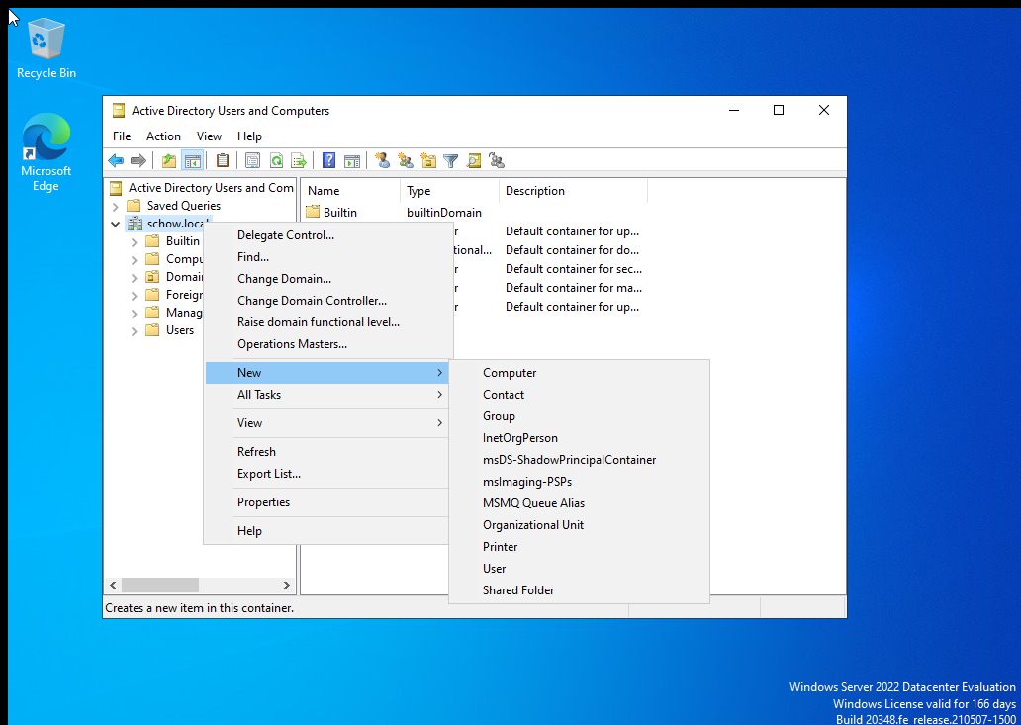

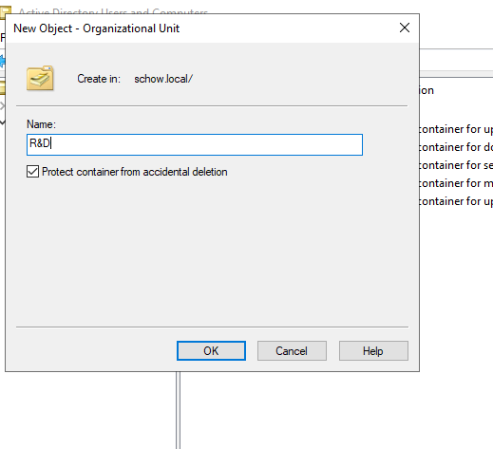

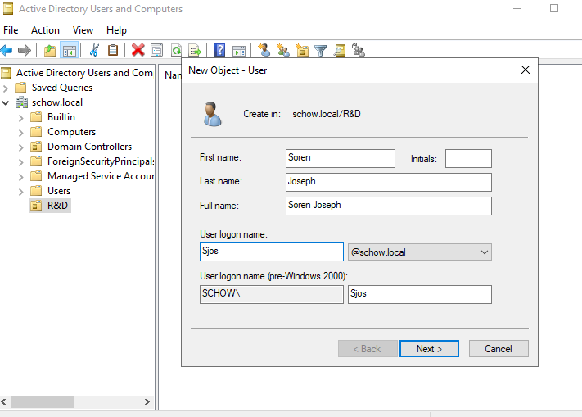

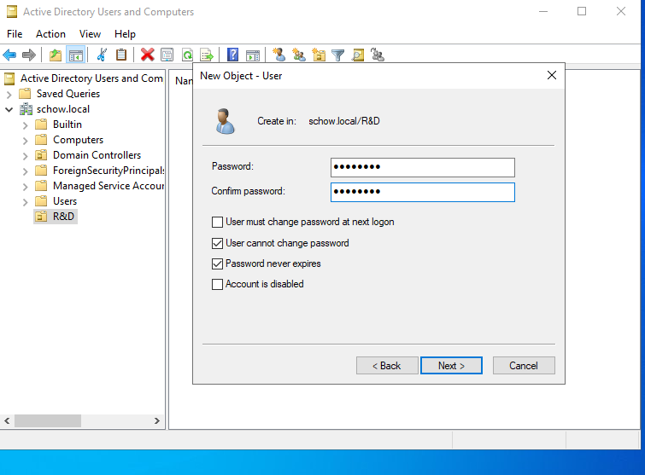

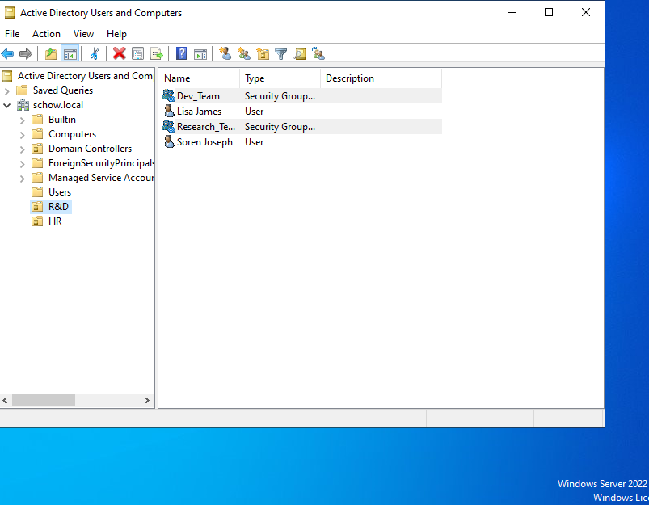

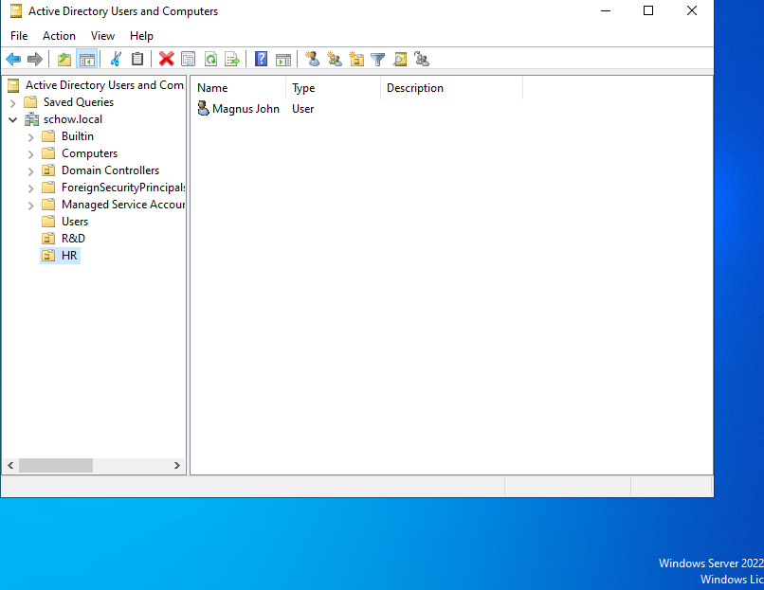

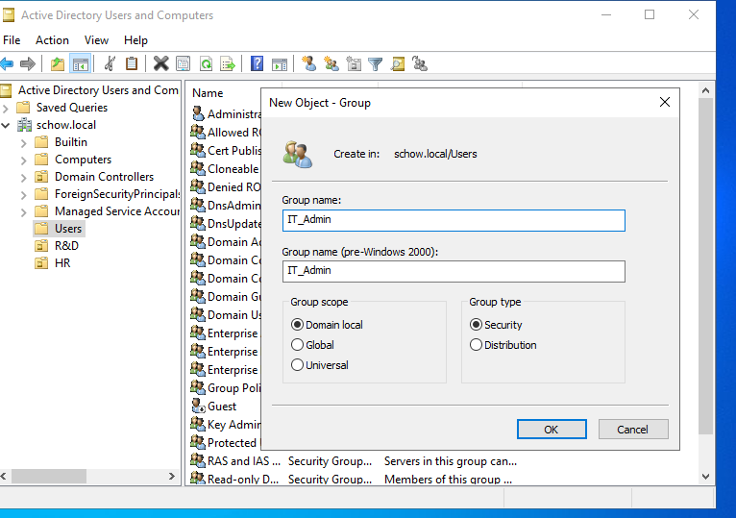

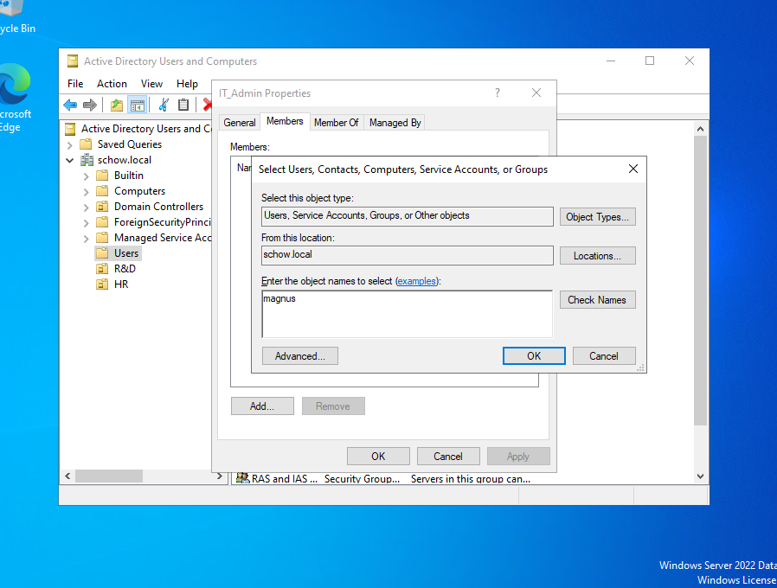

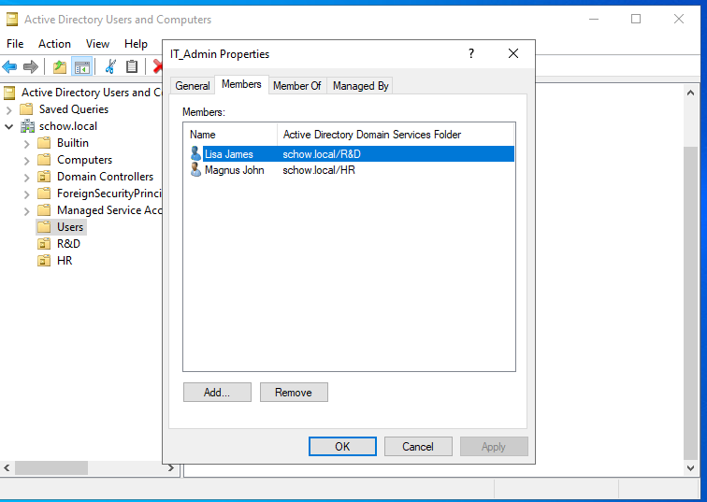

**Step 5: Connect a Windows Client Machine to the Domain.**

**5.1 Set Up Windows Client VM**

Start by creating a virtual machine running Windows 10/11 and proceed to install the ISO image using this link: [Windows 10 ISO image Download](https://windows-10.en.softonic.com/?utm_source=bing&utm_medium=paid&utm_campaign=Bing_EN_AU_DSA_Desktop_TP_6524&msclkid=671a4974d54819cefda02eda2f1e5df1)

**5.2 Configure Network**

Establish the Preferred DNS Server as the IP address of the Windows Server (e.g., 192.168.1.100).

**5.3 Join the Domain**

* Access System Properties then Change Settings to input the domain name such as mycompany.local.
* Authenticate with domain admin credentials → Restart.

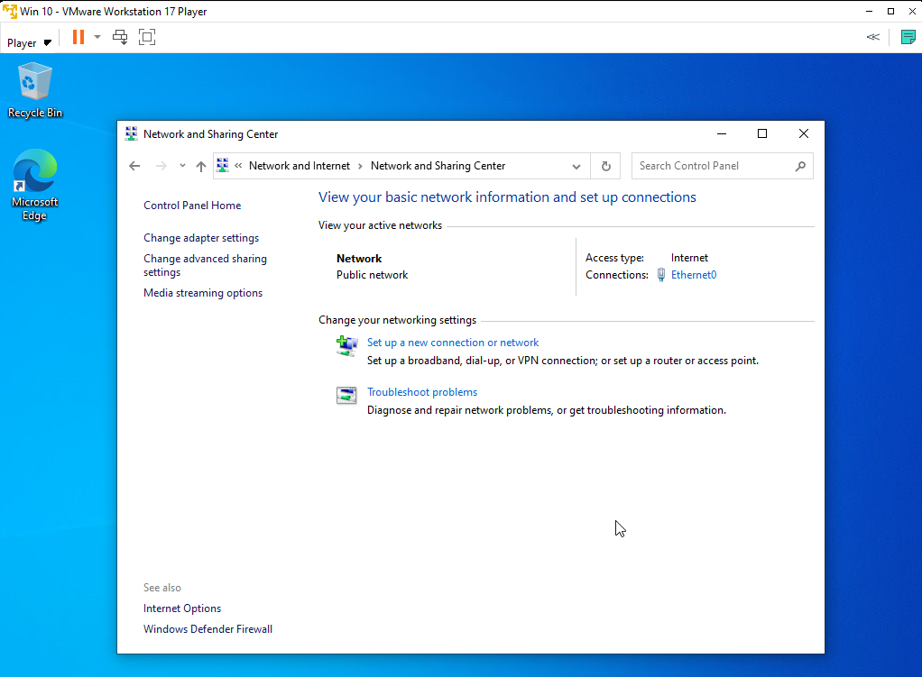

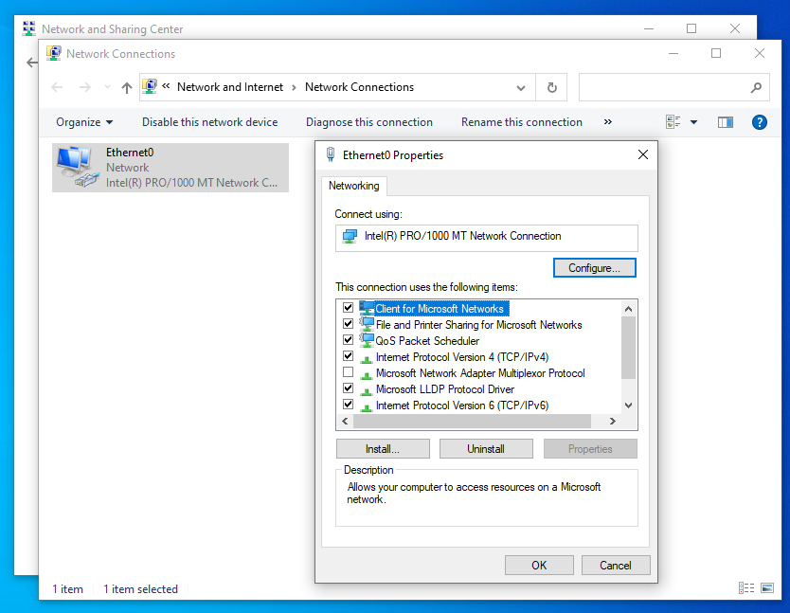

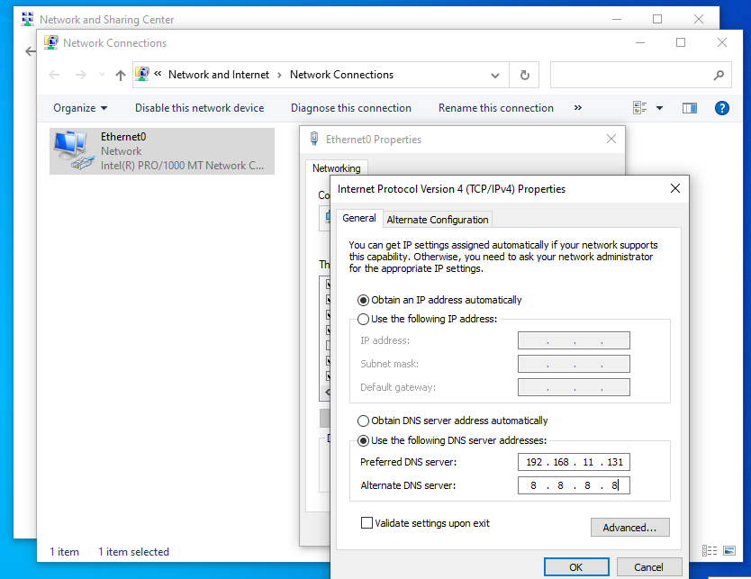

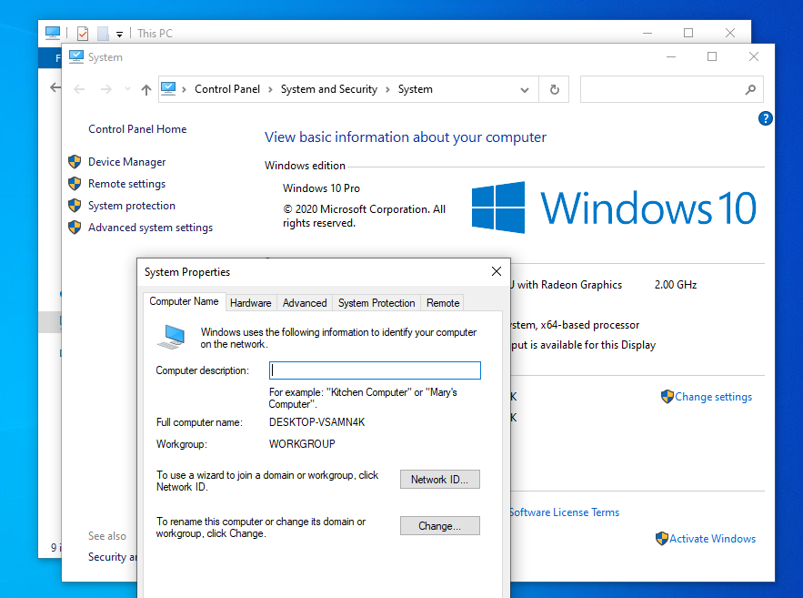

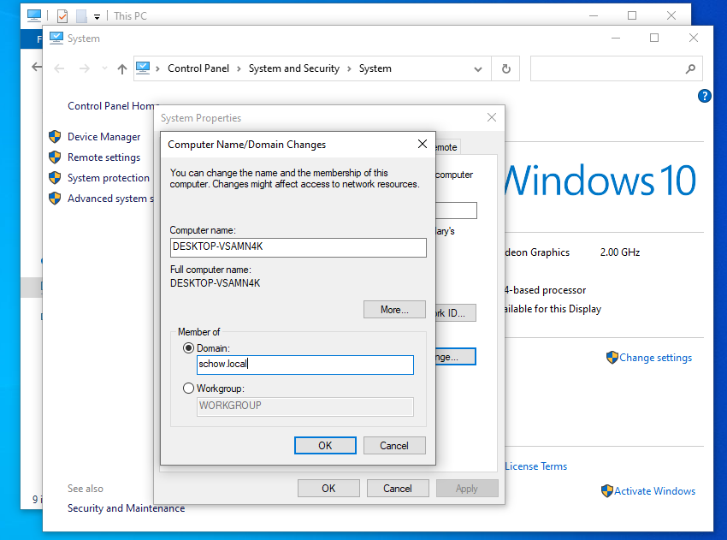

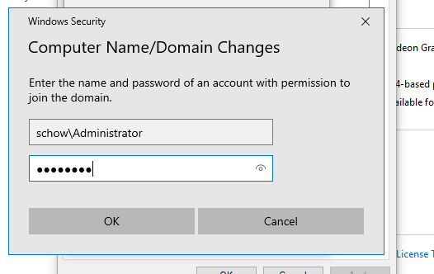

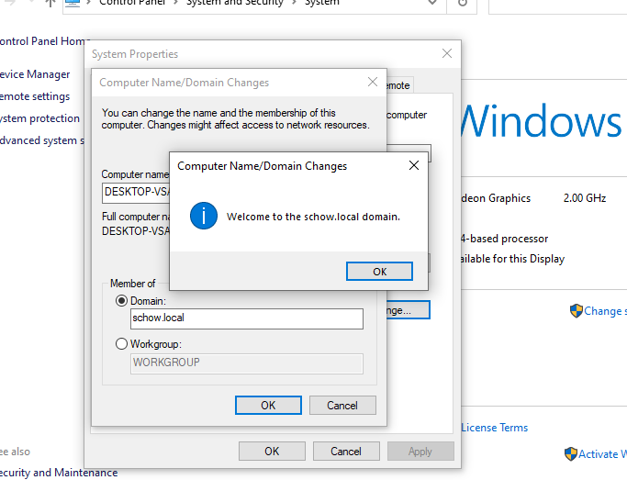

**5.4 Verify Domain Join**

* Log in as a domain user.
* Verify that the client machine appears in "Active Directory Users and Computers".

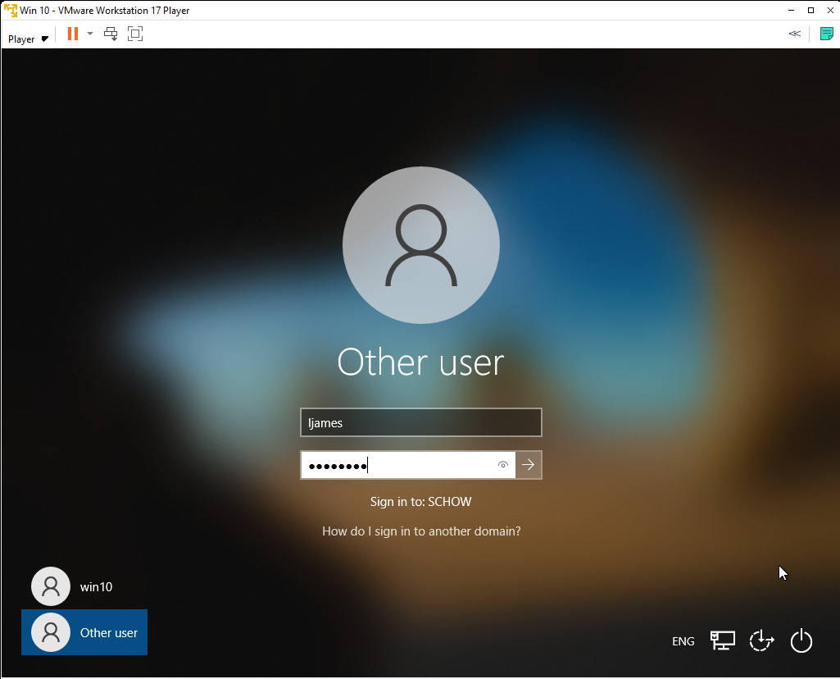

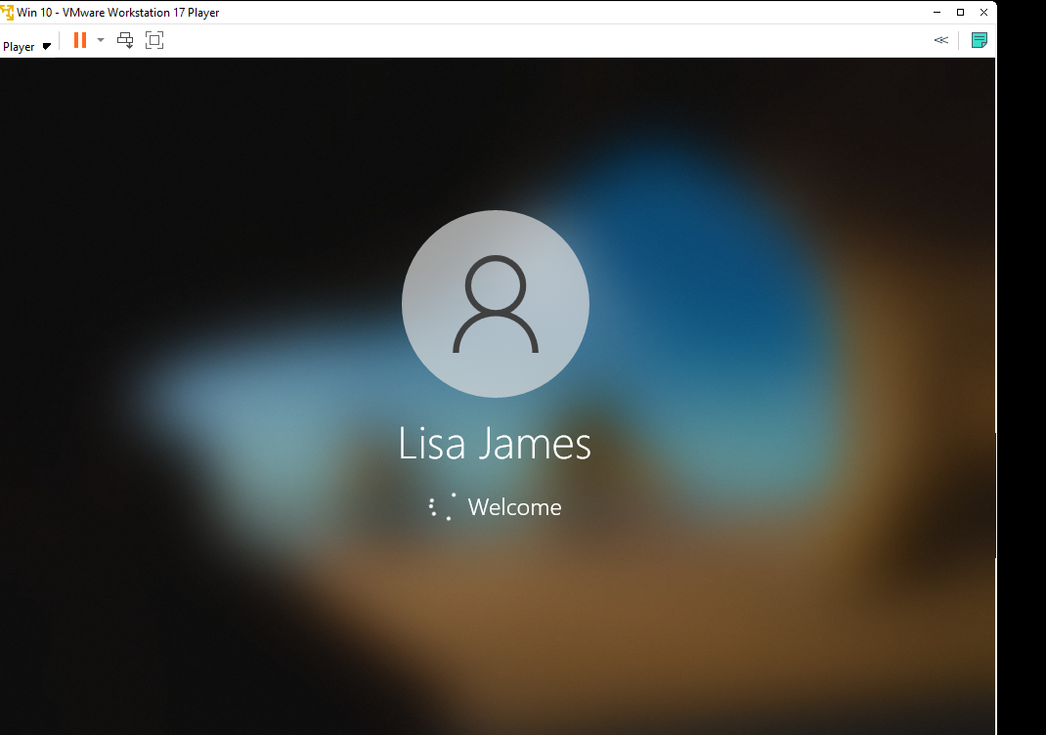

**Step 6: Configure Group Policies**

**6.1 Create a New GPO**

Access "Group Policy Management" and create a new GPO which should be named "Security Policy", “Password Policy”, etc and assign those policies to the Users or the specific groups.

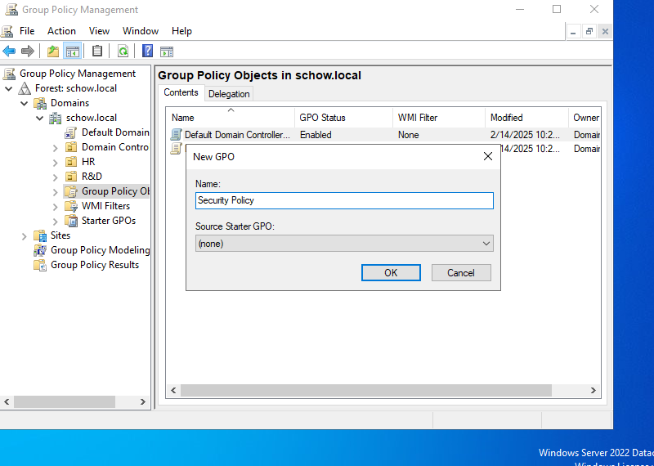

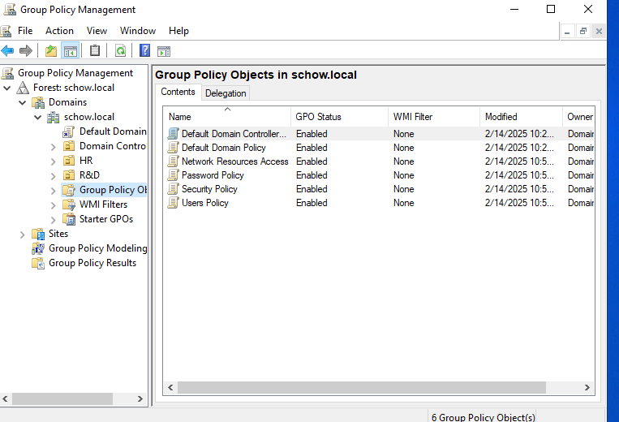

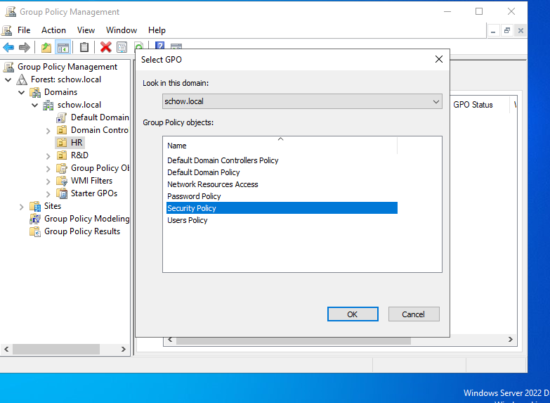

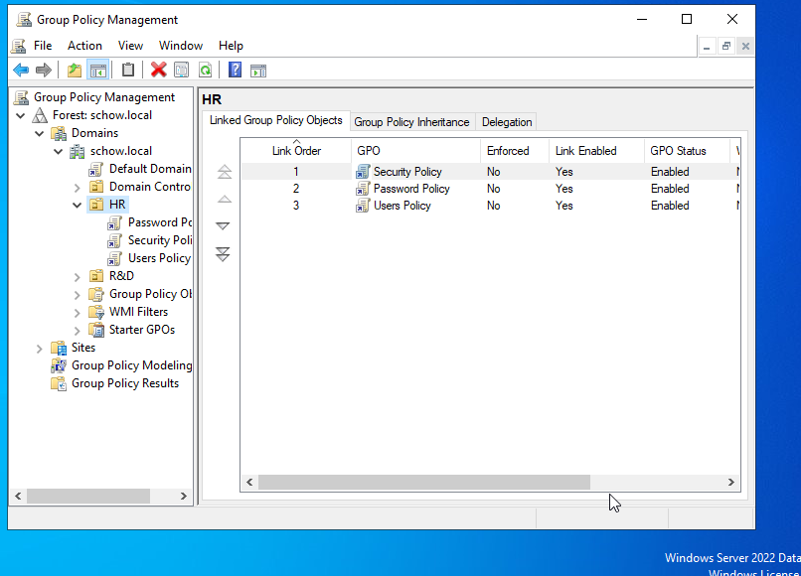

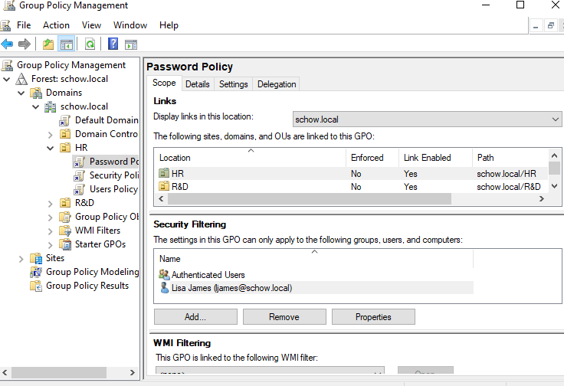

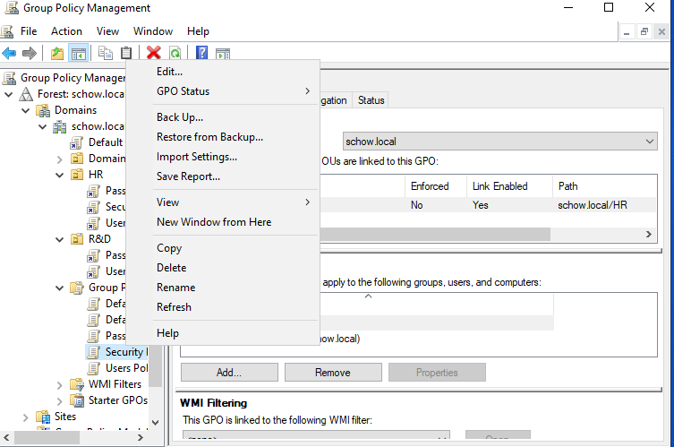

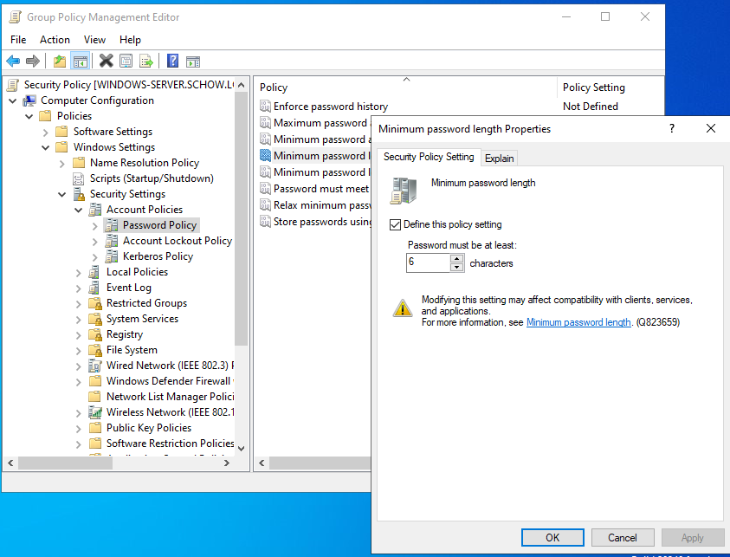

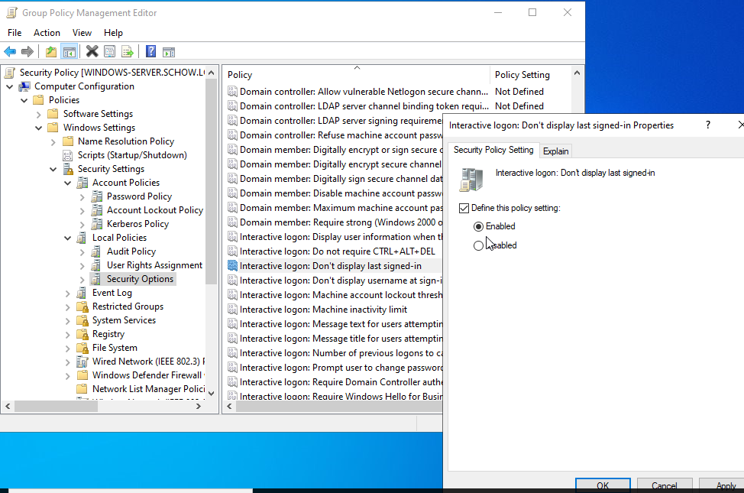

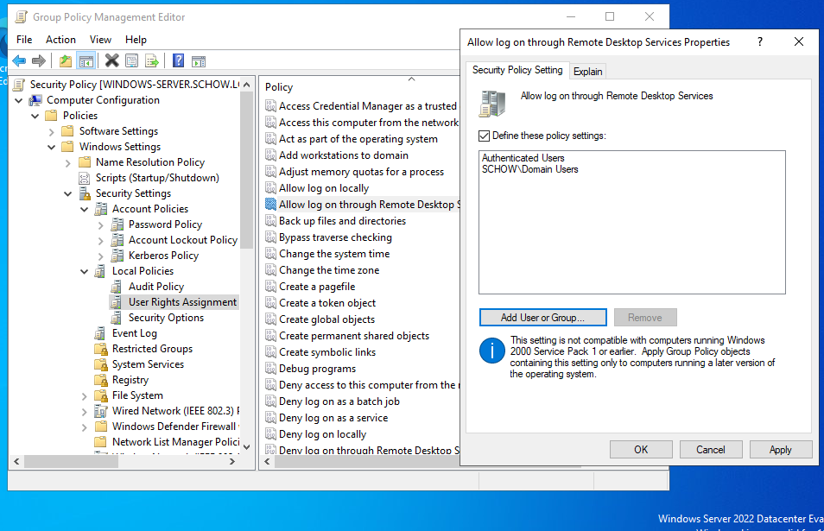

**6.2 Apply Policies**

* Access the GPO to modify settings including password policies and login restrictions.
* Apply using gpupdate /force.

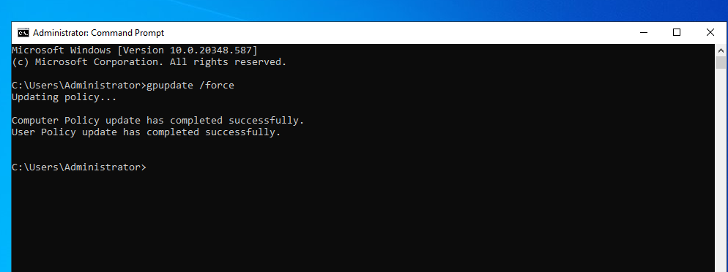

**Step 7: Configure File Sharing & Remote Access**

**7.1 Set Up a Shared Folder**

* Create folder (e.g., C:\SharedFiles) → Enable "Advanced Sharing".
* Configure permissions.

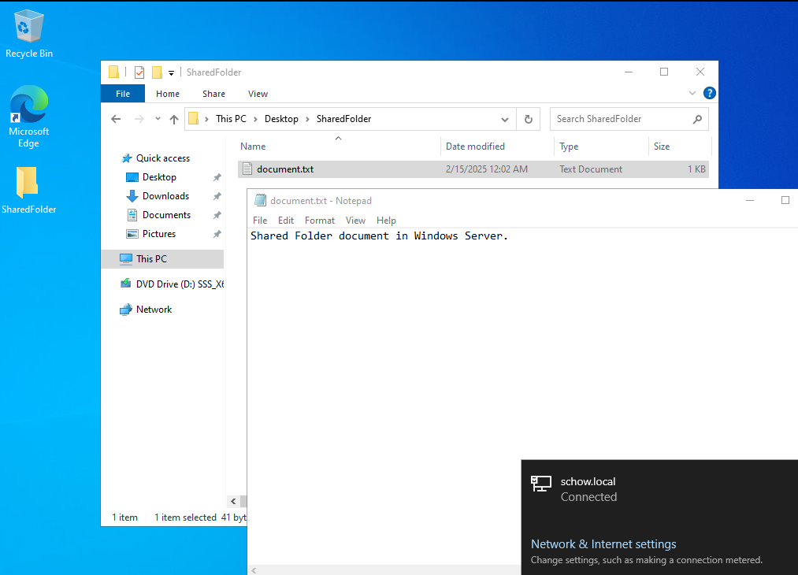

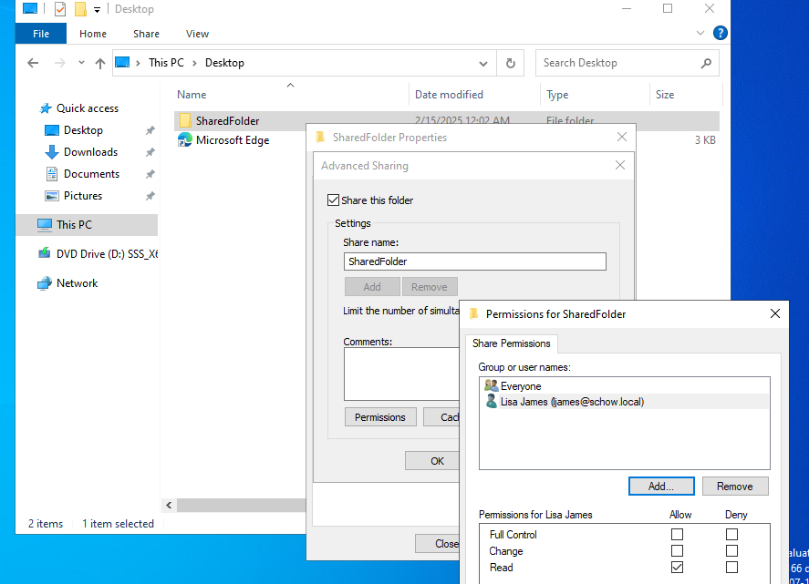

**7.2 Test Access**

Open “ \\ip-addressofWindowsServer\SharedFolderName”” or “\\WindowsServerName\SharedFolderName” from a client machine.

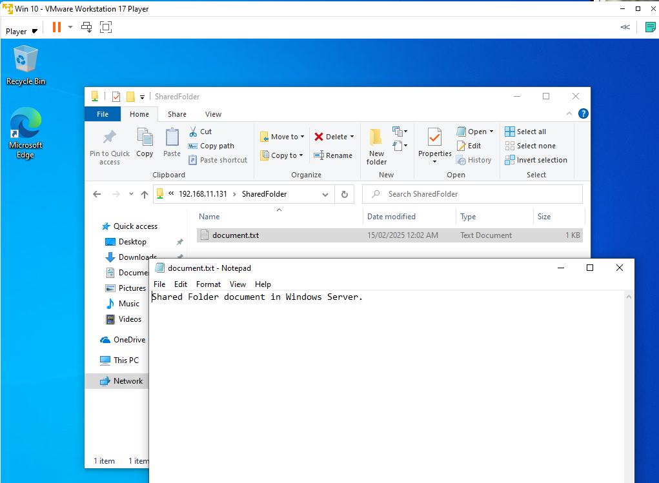

**Step 8: Install and Configure a Linux Server**

**8.1 Install Ubuntu Server**

Launch a virtual machine using Ubuntu ISO image to complete OS installation.

**8.2 Configure SSH**

sudo apt update && sudo apt upgrade -y

sudo apt install openssh-server -y

sudo systemctl enable ssh

sudo systemctl start ssh

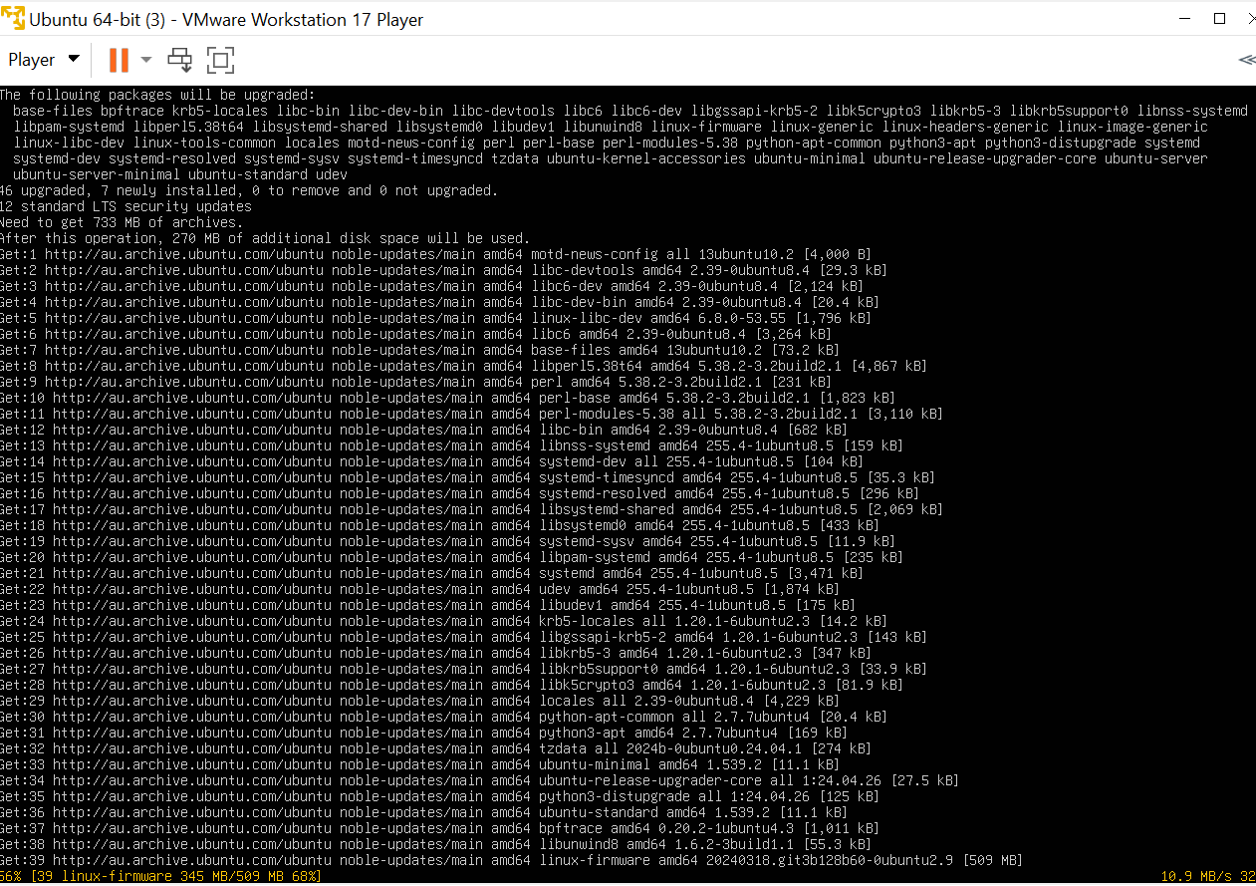

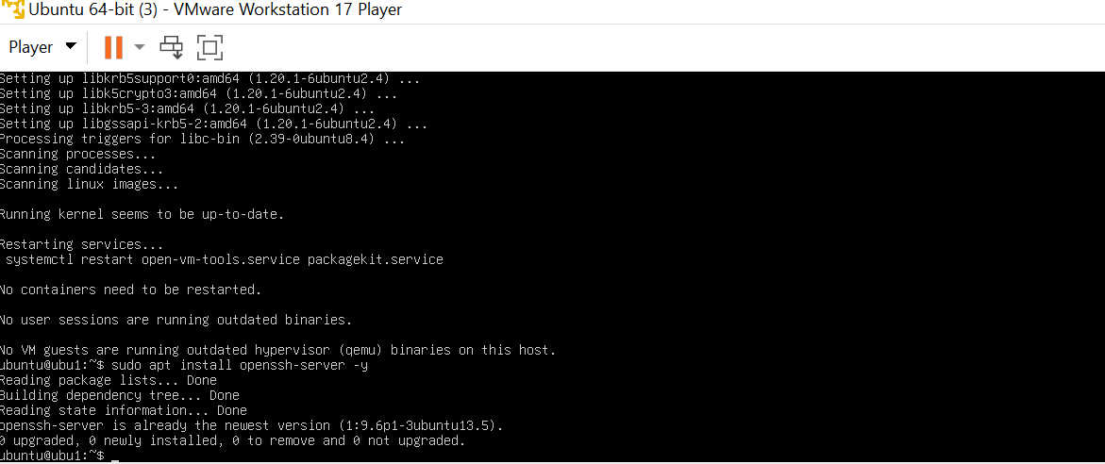



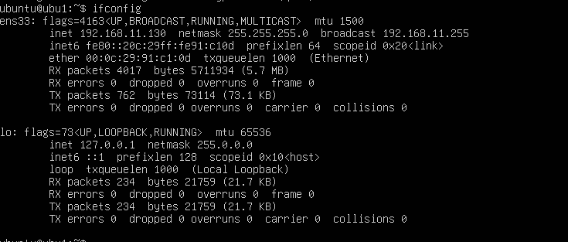



**8.3 Verify Connectivity**

ssh username@<linux-server-ip>

Here, I have verified connectivity of the Ubuntu server using Windows Client Virtual Machine.

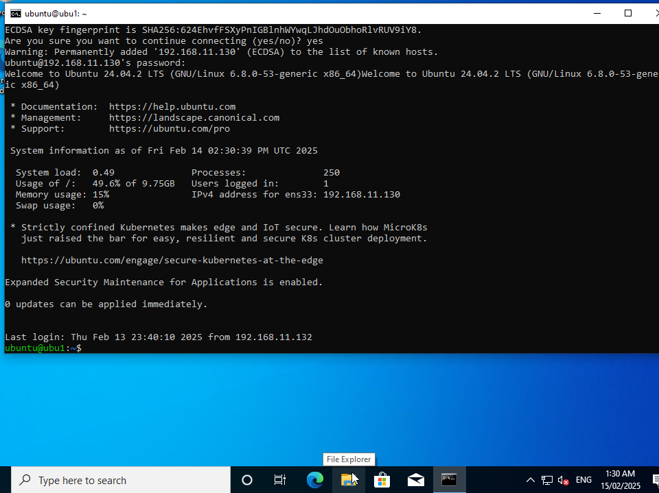

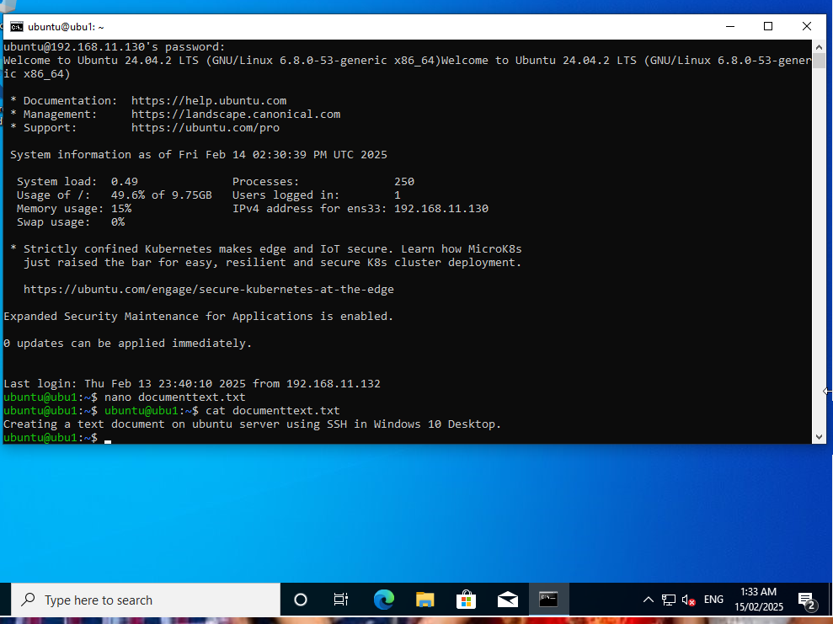

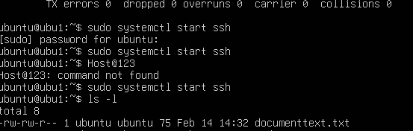

**Step 9: Deploy Cloud Services on AWS**

**9.1 AWS Setup**

* Sign up for AWS Free Tier.
* Launch an EC2 instance (t2.micro, Ubuntu/Windows).

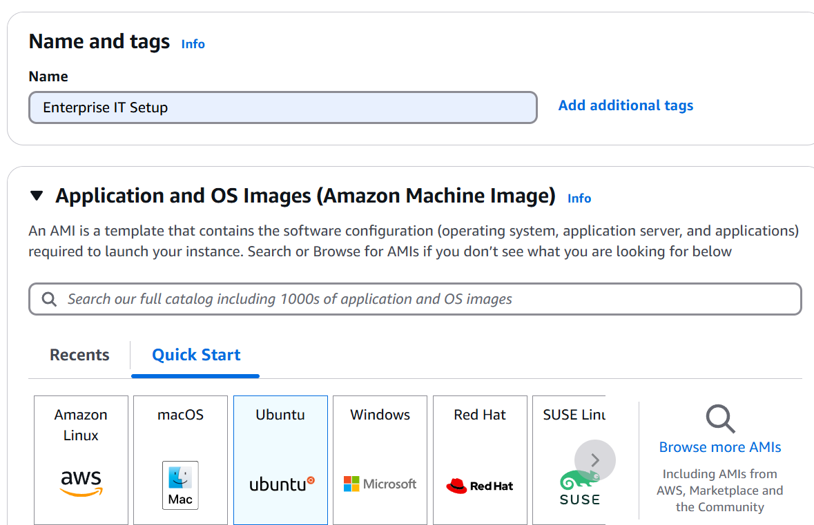

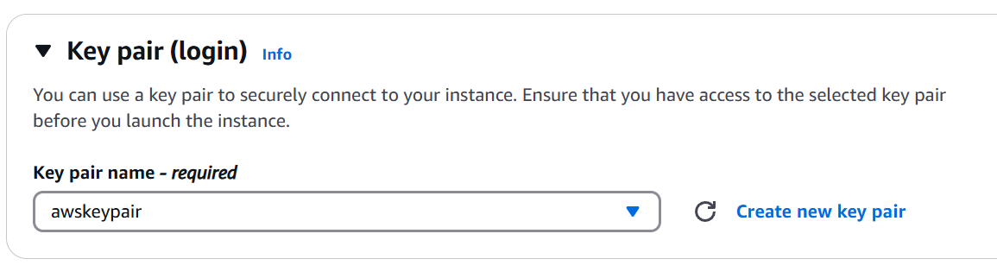

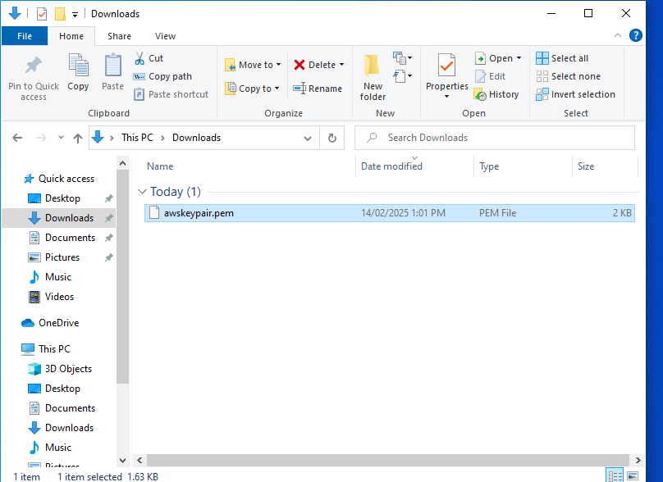

* Configure Security Group (Allow SSH 22/RDP 3389).
* Connect via SSH or RDP.

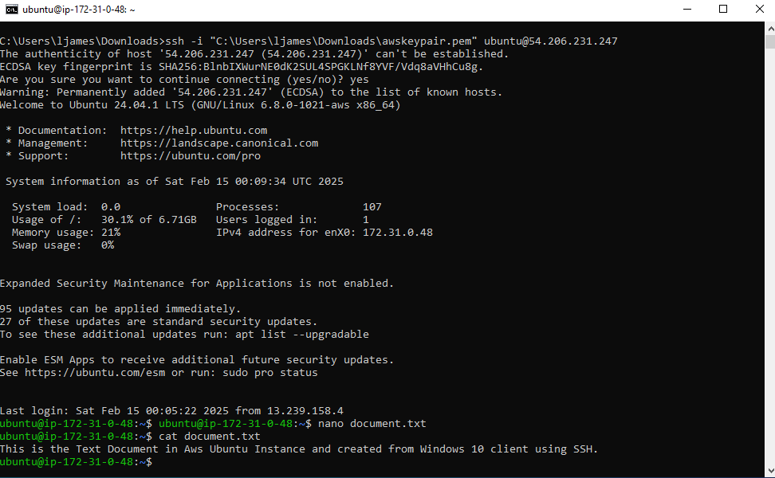

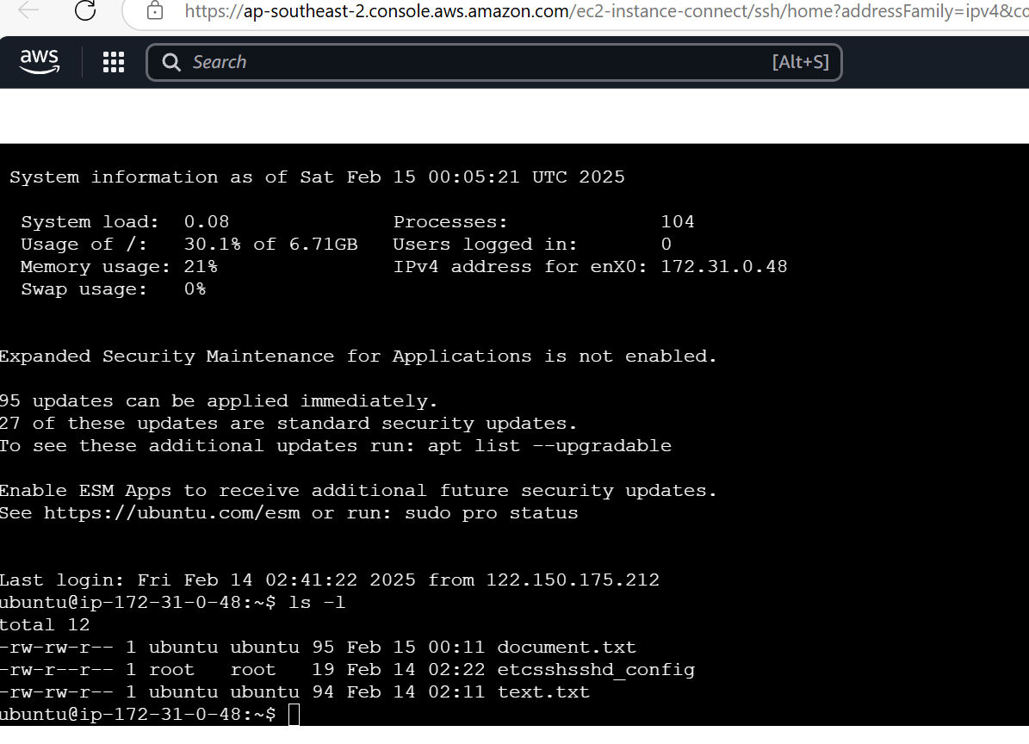

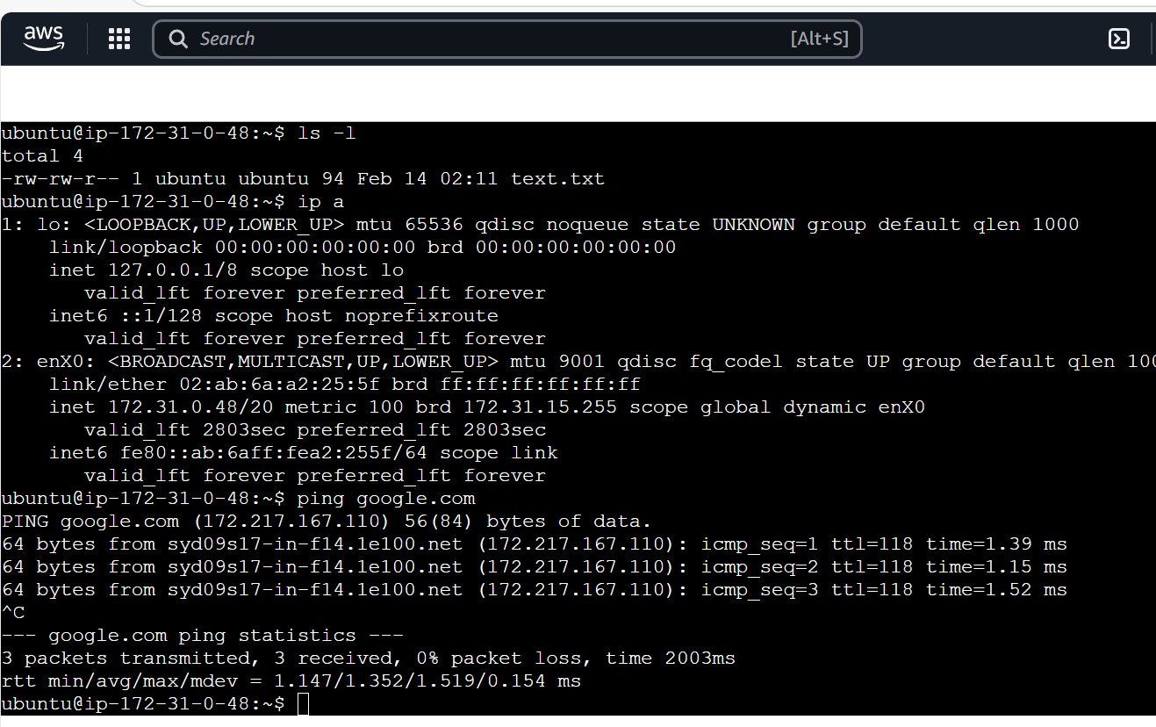

* Create a new user and add a grant sudo (Admin) Access to the new user.
* Disable root login via SSH.
* Test the root login, it should be denied
* Log in as the New User
* Verify “sudo” Access for the New User
* Switch User While Logged In
* Check the details of new user using command “id user”
* View User Account Details using command “getent passwd newuser”

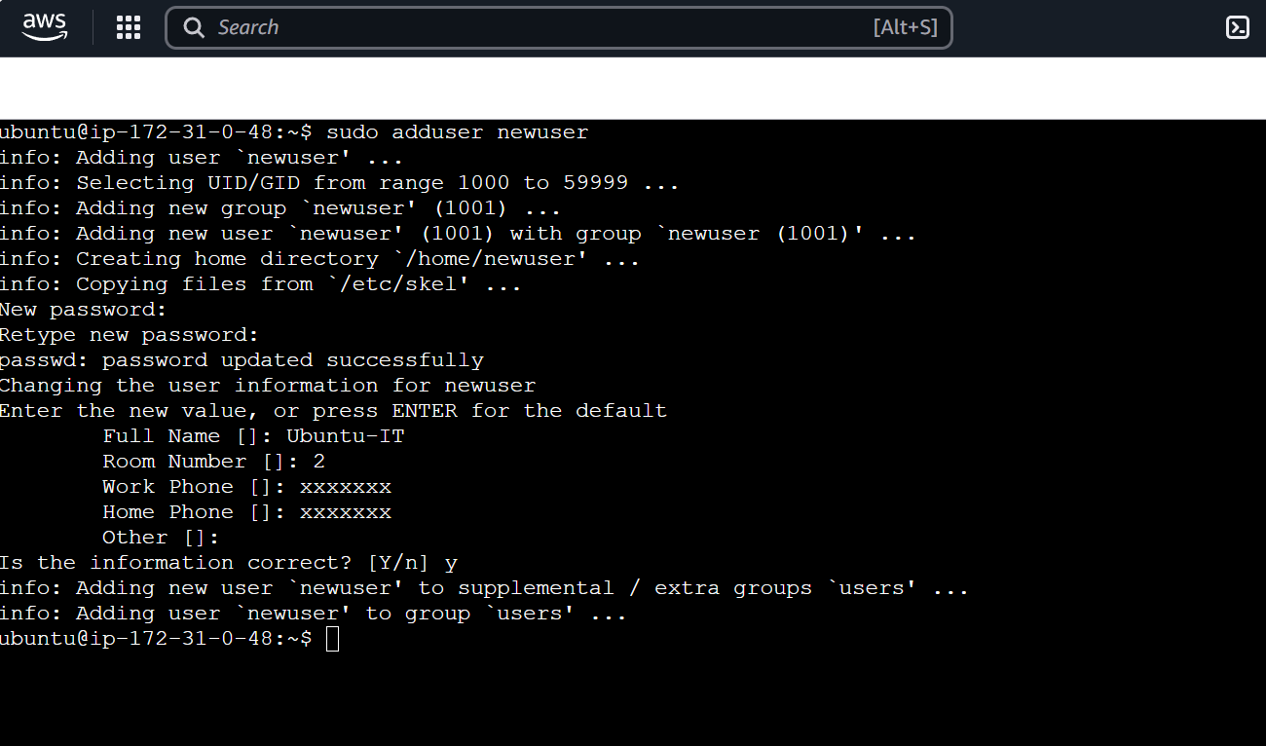

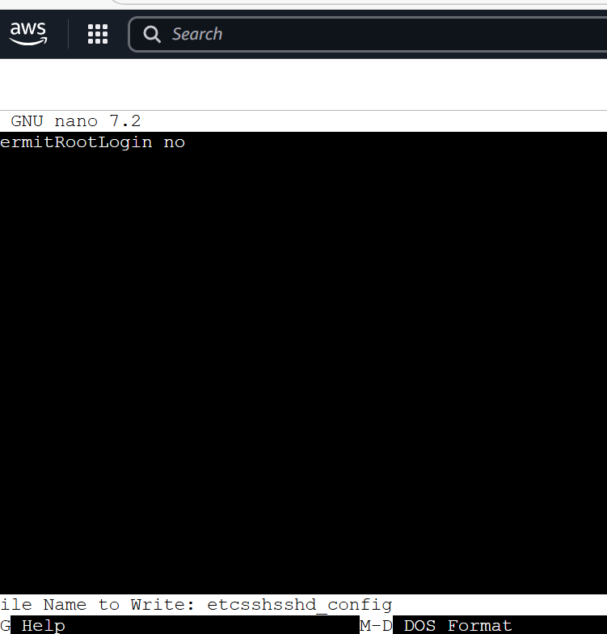

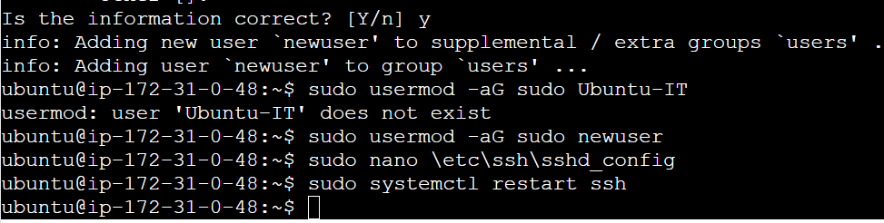



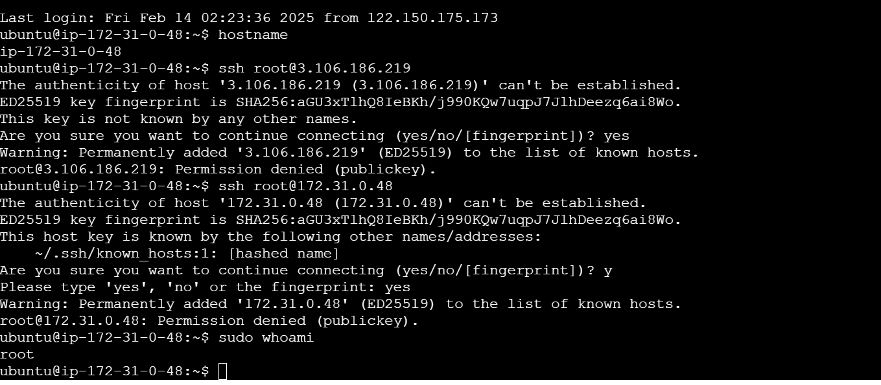

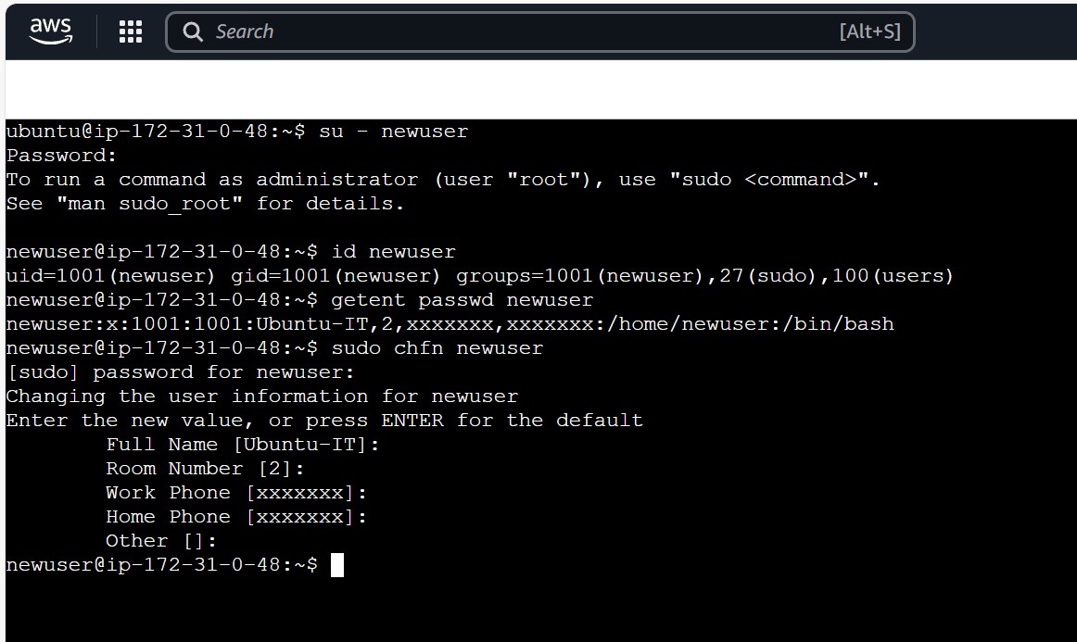

**Conclusion**

This documentation includes a full sequential guide to establish a Windows Server environment while configuring Active Directory and connecting clients, and it allows implementation of security policies with optional cloud service deployment. Success in deployment depends on following each step with precision.

**Done by**

Srija Chowdary